**Topics: Descriptive Statistics and Probability**

1. Look at the data given below. Plot the data, find the outliers and find out $μ, σ, σ^{2}$

|  |  |
| --- | --- |
| **Name of company** | **Measure X** |
| Allied Signal | 24.23% |
| Bankers Trust | 25.53% |
| General Mills | 25.41% |
| ITT Industries | 24.14% |
| J.P. Morgan & Co. | 29.62% |
| Lehman Brothers | 28.25% |
| Marriott | 25.81% |
| MCI | 24.39% |
| Merrill Lynch | 40.26% |
| Microsoft | 32.95% |
| Morgan Stanley | 91.36% |
| Sun Microsystems | 25.99% |
| Travelers | 39.42% |
| US Airways | 26.71% |
| Warner-Lambert | 35.00% |

Name of the companies with respect to x

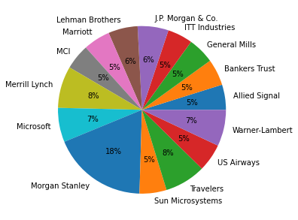

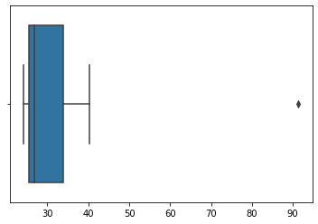

The following is the outlier in the boxplot: Morgan Stanley 91.36%

## Mean

Measure. mean() = 33.27133333333333

## Variance

Measure. Var () = 287.1466123809524

## Standard Deviation

Measure. Std () = 16.945400921222028



Answer the following three questions based on the box-plot above.

1. What is inter-quartile range of this dataset? (Please approximate the numbers) In one line, explain what this value implies.

Ans: Q3 = 12, Q1 = 5

IQR = Upper Quartile (Q3) - Lower Quartile (Q1) = 12 – 5 = 7

This value implies the Median value, that is second quartile(Q2).

1. What can we say about the skewness of this dataset?

Ans: Right Skewed Median is towards the left side. It is not a normal distribution.

1. If it was found that the data point with the value 25 is actually 2.5, how would the new box-plot be affected?

Ans: There would be no outliers on the given dataset because of the outlier data is having positive skewness. The positive skewness will reduce and the data will be normal distribution.



Answer the following three questions based on the histogram above.

1. Where would the mode of this dataset lie?

Ans: The mode of this dataset would lie in between exactly between 4 to 8.

1. Comment on the skewness of the dataset.

Ans: The dataset is Right skewed mean>median.

1. Suppose that the above histogram and the box-plot in question 2 are plotted for the same dataset. Explain how these graphs complement each other in providing information about any dataset.

Ans: They both are right-skewed data and both have the outliers approximately 25. The median can be seen easily in boxplot whereas mode can be seen easily in histogram.

1. AT&T was running commercials in 1990 aimed at luring back customers who had switched to one of the other long-distance phone service providers. One such commercial shows a businessman trying to reach Phoenix and mistakenly getting Fiji, where a half-naked native on a beach responds incomprehensibly in Polynesian. When asked about this advertisement, AT&T admitted that the portrayed incident did not actually take place but added that this was an enactment of something that “could happen.” Suppose that one in 200 long-distance telephone calls is misdirected. What is the probability that at least one in five attempted telephone calls reaches the wrong number? (Assume independence of attempts.)

Ans: If 1 in 200 long-distance telephone calls are getting misdirected then

Probability of call misdirecting = 1/200

Probability of call not Misdirecting = 1-(1/200) = 199/200

n = 5, p = 1/200, q = 199/200

P(x) = at least one in five attempted telephone calls reaches the wrong number

= ⁿCₓ pˣ qⁿ⁻ˣ , P(x) = (nCx) (p^x) (q^n-x) # nCr = n! / r! * (n - r)!

P (1) = (5C1) (1/200) ^1 (199/200) ^5-1 = 0.0245037

1. Returns on a certain business venture, to the nearest $1,000, are known to follow the following probability distribution

|  |  |
| --- | --- |
| x | P(x) |
| -2,000 | 0.1 |
| -1,000 | 0.1 |
| 0 | 0.2 |
| 1000 | 0.2 |
| 2000 | 0.3 |
| 3000 | 0.1 |

1. What is the most likely monetary outcome of the business venture?

Ans: The most likely monetary outcome of the business venture is $2000 because for 2000$ the probability is 0.3 which is maximum as compared to others.

1. Is the venture likely to be successful? Explain

Ans: Yes, the probability that the venture will make more profit

p(x>0) + p(x>1000) + p(x>2000) + p(x=3000) = 0.2+0.2+0.3+0.1 = 0.8 this states that there is good 80% chances for this venture to be making a profit

1. What is the long-term average earning of business ventures of this kind? Explain

Ans: The long-term average is Expected value = Sum (X * P(X)) = 800$ which means on an average the returns will be + 800$

1. What is the good measure of the risk involved in a venture of this kind? Compute this measure

Ans:  The good measure of the risk involved in a venture of this kind depends on the Variability in the distribution. Higher Variance means more chances of risk

Var (X) = E(X^2) –(E(X)) ^2 = 2800000 – (800^2) = 2160000